Transmitted Via Electronic Mail

October 21, 2024

Benjamin J.F. Cruz

Public Auditor

Office of Public Accountability

238 Archbishop Flores St.

Hagatna, Guam 96910

RE: Procurement Training Compliance Report FY2024

Hafa Adai,

Pursuant to 5 GCA §5141(n), the Office of Infrastructure Policy & Development is submitting this Annual Report FY 2024.

|  |  |  |  |
| --- | --- | --- | --- |
| Name | Job Title | Date | Module |
| Melissa Bettis | Special Assistant | April 9, 2024 | Module 1 |
| Cristina Tenorio | Staff Assistant | February 27, 2024 | Module 1 |

Should you have any questions please feel free to contact me at 671-646-2323.

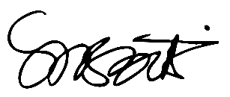

Melissa Bettis

Acting Director

Office of Infrastructure Policy & Development

OFFICE OF THE GOVERNOR OF GUAM